Authoring Application

User Manual

Group 2

EECS 2311

Midterm Submission

February 23rd 2018

# Table Of Contents

**Table Of Contents** **2**

**Welcome to the Authoring Application** **3**

0.00 - What is the Authoring Application? 3

0.01 - What is Braille? 3

0.02 - Basic Functionality of our Application 3

0.03 - Our Scenario Interactions 4

**Getting Started** **5**

1.00 - Running the Application 5

1.01 - Creating a New Scenario 6

1.02 - Editing an Existing Scenario 7

**Creating/Editing Interactions and Scenarios** **8**

2.00 - Creating a new Interaction 8

2.01 - Deleting an Interaction 10

2.02 - Customizing a ‘Read’ Interaction 10

2.03 - Customizing a ‘Display braille’ Interaction 11

2.04 - Customizing a ‘Keyword’ Interaction 12

2.05 - Customizing a ‘Pause’ Interaction 13

2.06 - Customizing a ‘Skip button’ Interaction 14

2.07 - Customizing a ‘User input’ Interaction 15

2.08 - Customizing a ‘Reset button’ Interaction 16

2.09 - Customizing a ‘Clear braille’ Interaction 17

2.10 - Saving your Scenario 18

2.11 - Running your Scenario 19

# 

# Welcome to the Authoring Application

## 0.00 - What is the Authoring Application?

The Authoring Application is a unique tool built to aid instructors in teaching braille to both visually capable and incapable individuals who may need it in their daily lives. Our aim is to create a better environment for teachers and students alike. The Authoring Application is easy to use, and will allow for instructors to create their very own lessons which can later be viewed by their students at any time.

## 0.01 - What is Braille?

Braille is a form of written language, in which characters are represented by patterns of raised dots that are felt with the fingertips. Our lessons (or scenarios) which instructors will be able to create using our application can be run and will launch a viewer which will allow users to view the scenario, these scenarios will show users a virtual representation of braille cells.

## 0.02 - Basic Functionality of our Application

In this release of the Authoring Application, you will be able to:

* Create new scenarios and save them to run them or work on them at a later time
* Open existing scenarios and add/remove/edit interactions as well as save any changes made
* Test scenarios in the braille cell simulator from within the authoring app

You will use this application to create lessons (called scenarios) to teach students the braille language. Each scenario you build will be made up of a number of interactions. All interactions are fully customizable and can be ordered in any way the instructor desires. For example, the ‘Read’ interaction is a simple interaction which will read its data to the user viewing the lesson. An instructor may read a question out to the user, followed by displaying a combination of raised braille pins using the ‘Display braille’ interaction, and demand an answer be given by clicking one of the buttons on the lesson window.

## 0.03 - Our Scenario Interactions

Our current release supports the following interactions:

* Read interaction
* Skip button interaction
* Display braille interaction
* Receive user input interaction
* Clear braille cell interaction
* Reset buttons interaction
* Pause interaction
* Keyword interaction

# Getting Started

## 1.00 - Running the Application

Once you have downloaded and extracted our application, you must navigate to the folder which you extracted our program into. The folder will be called AuthoringApp_vM, inside of it will be another folder called AuthoringApp_vM, that is the folder which contains the application, run (double-click) the AuthoringApp_vM.jar file in that folder. Upon running the application, the application will launch and you will be brought to the main menu, which will look like this:

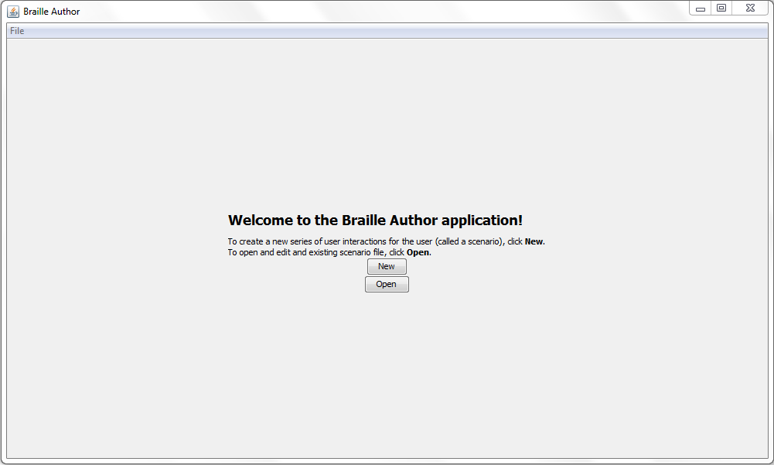

## 1.01 - Creating a New Scenario

From the main menu, you have the option to create a new scenario by clicking the ‘New’ button. After clicking the ‘New’ button, you will be brought to the new scenario configuration window. Here you **must** specify the scenario title, the number of braille cells (1-8, use the arrows or type the number), and the number of buttons (1-10, use the arrows or type the number) which your new scenario will have. You will do this by filling out their fields respectively:

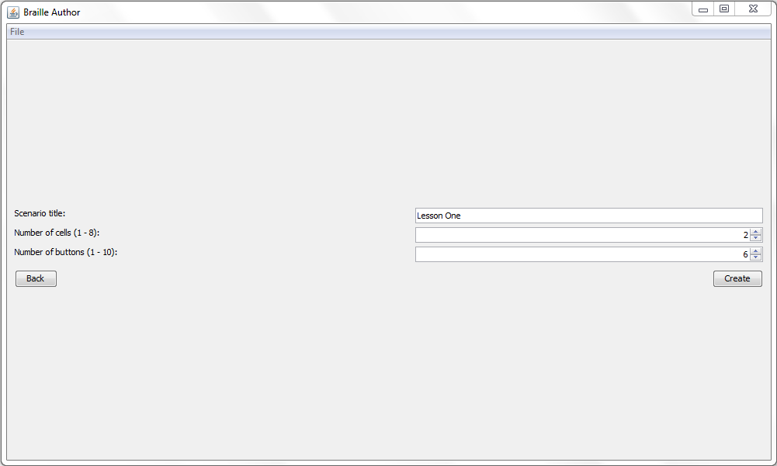

Once you have finished filling out the fields and are ready to create the scenario, click the ‘Create’ button. Otherwise, if you have changed your mind, click the ‘Back’ button to return to the main menu. All new scenarios you create will be saved in the same folder you run our application from (the folder named AuthoringApp_vM which contains the AuthoringApp_vM.jar file), each scenario is saved within a .txt file named after the title you gave it.

## 1.02 - Editing an Existing Scenario

From the main menu, you have the option to edit an existing scenario by clicking the ‘Edit’ button. Clicking this button will bring up a small file chooser window, which will allow you to navigate to the scenario .txt file you wish to make changes to, and open it. The window will look like this:

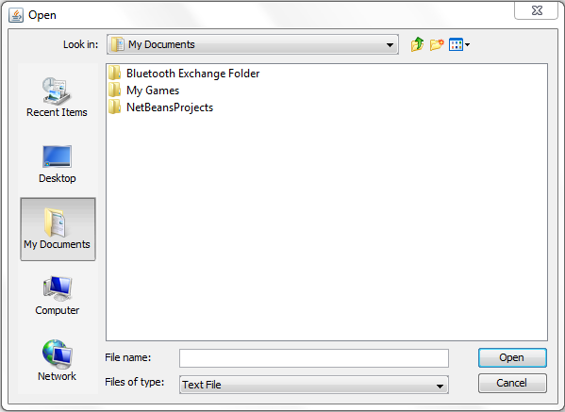

All new scenarios you create will be saved in the same folder you run our application from (the folder named AuthoringApp_vM which contains the AuthoringApp_vM.jar file), each scenario is saved within a .txt file named after the title you gave it. Upon opening a scenario .txt file from the file chooser window, you will then be brought to the editor window:

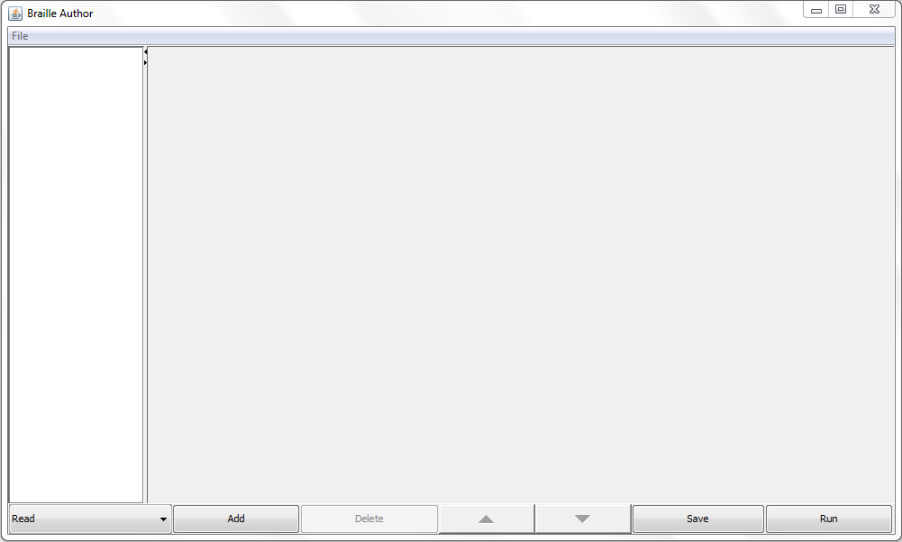

Detailed instructions on how to create/delete/edit interactions can be found below.

# Creating/Editing Interactions and Scenarios

## 2.00 - Creating a new Interaction

From the editor window, you can create a new interaction by clicking the drop-down at the bottom left corner of the window, selecting the desired interaction you wish to create and then clicking the ‘Add’ button beside the dropdown. The drop-down contains a full list of all of our available interactions (currently the ‘Voice’ interaction is not functioning) and will look like this:

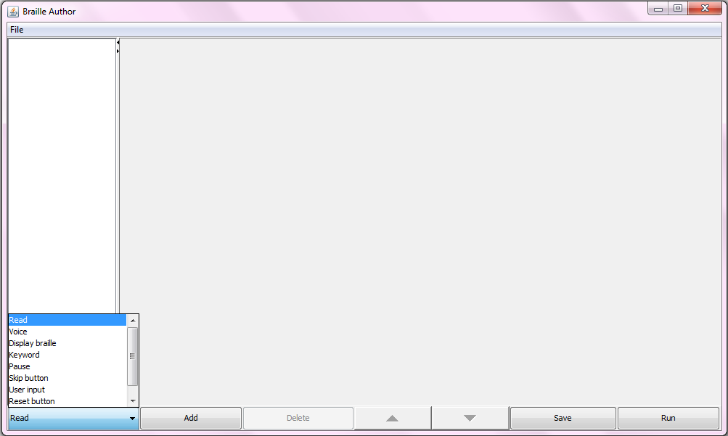

As you can see, the ‘Add’ button is directly beside the drop-down. Once you have added interactions to your scenario, you may re-order them freely by using the up and down arrows located between the ‘Delete’ and ‘Save’ buttons. Simply click on the interaction you wish to move and click the up arrow button to switch its place with the interaction above it, or click the down arrow button to switch its place with the interaction below it.

## 2.01 - Deleting an Interaction

If there is an interaction you would like to delete, click on it in the left panel, and you will be able to delete it by clicking the ‘Delete’ button which is beside the ‘Add’ button.

## 2.02 - Customizing a ‘Read’ Interaction

After adding a ‘Read’ interaction, click on it in the left panel and you will see the editor for the interaction appear on the right panel like so:

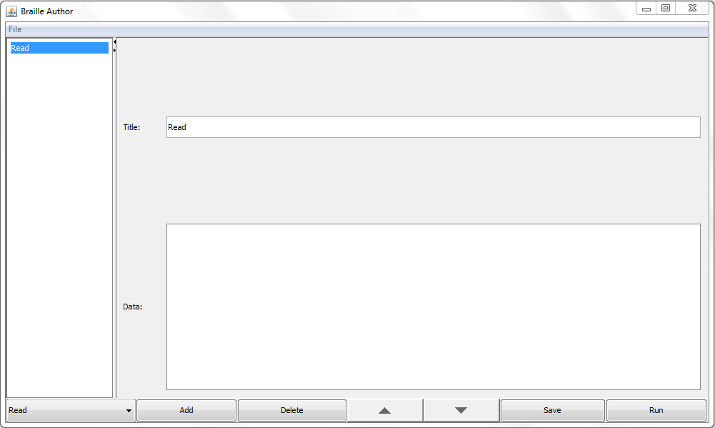

From here you should fill out the two fields, the above field is for the title of the interaction, which only matters for the name of the card which you see on the left panel. The text you put in the ‘Data:’ field is what will determine what the ‘Read’ interaction will read out to the user at that point in the scenario.

## 2.03 - Customizing a ‘Display braille’ Interaction

After adding a ‘Display braille’ interaction, click on it in the left panel and you will see the editor for the interaction appear on the right panel like so:

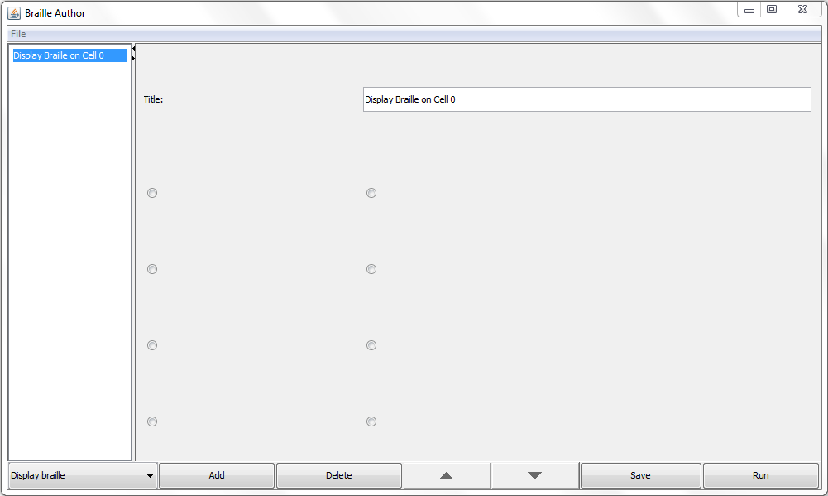

From here you can add a meaningful title to the interaction (eg. Display letter ‘A’). You also may specify which braille pins will be raised, the circles you select will be the pins which will be raised. You may freely select and deselect pins if you make a mistake or need to change something.

## 2.04 - Customizing a ‘Keyword’ Interaction

After adding a ‘Keyword’ interaction, click on it in the left panel and you will see the editor for the interaction appear on the right panel like so:

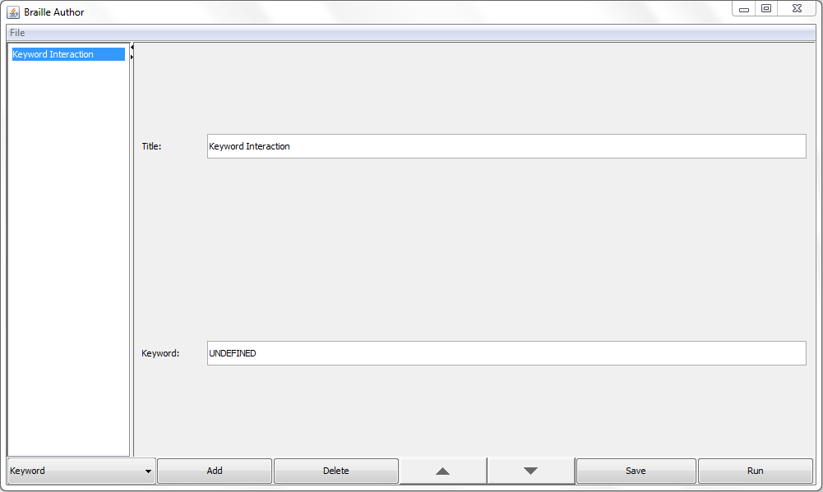

From here you may give your interaction a meaningful title to be displayed in the cards on the left by filling out the first field. Use this keyword interaction in combination with a button press interaction in order to link the two! When the student clicks on the button linked to this corresponding keyword, it will bring the student to this part of the scenario.

## 2.05 - Customizing a ‘Pause’ Interaction

After adding a ‘Pause’ interaction, click on it in the left panel and you will see the editor for the interaction appear on the right panel like so:

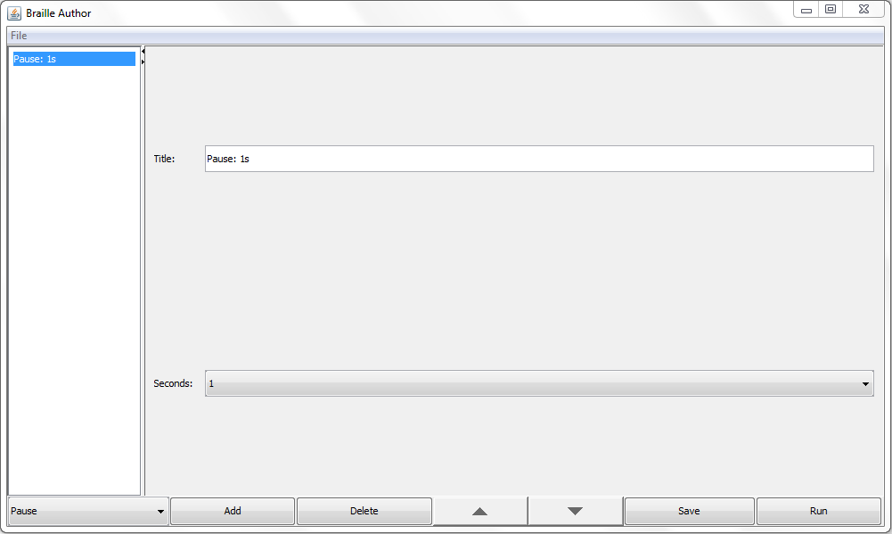

From here you may give the interaction a title by filling out the first field (eg. 3 second pause). You may also specify the duration of the pause you want to take place at this point in the scenario (0-19 seconds).

## 2.06 - Customizing a ‘Skip button’ Interaction

After adding a ‘Skip button’ interaction, click on it in the left panel and you will see the editor for the interaction appear on the right panel like so:

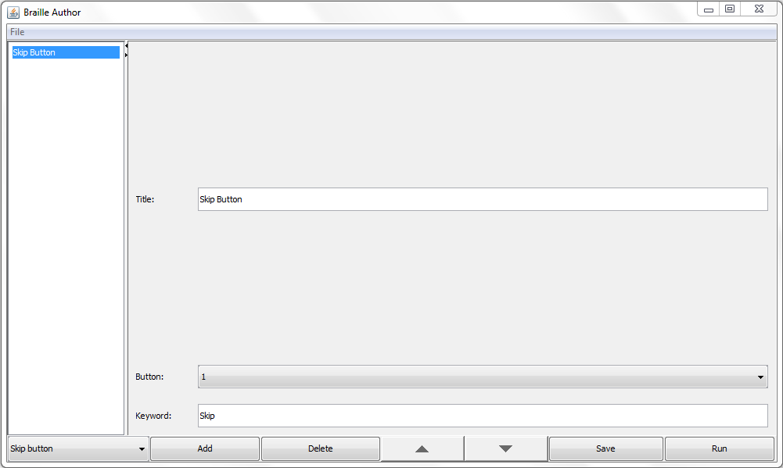

From here you may give the interaction a meaningful title by filling out the first field. The skip button is used to link a button press to a keyword. Use this to assign a keyword to jump to when the student presses a particular button.

## 2.07 - Customizing a ‘User input’ Interaction

After adding a ‘User input’ interaction, click on it in the left panel and you will see the editor for the interaction appear on the right panel like so:

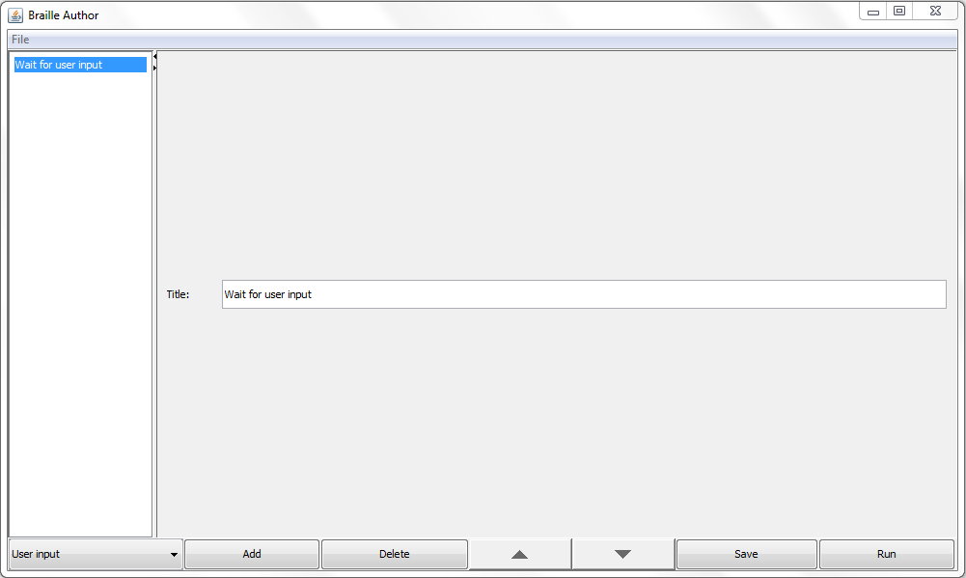

From here you may only customize the title of this interaction. The ‘User input’ interaction will make your scenario wait for the user’s input at this point in the scenario, the scenario will not proceed until the user has clicked a button.

## 2.08 - Customizing a ‘Reset button’ Interaction

After adding a ‘Reset button’ interaction, click on it in the left panel and you will see the editor for the interaction appear on the right panel like so:

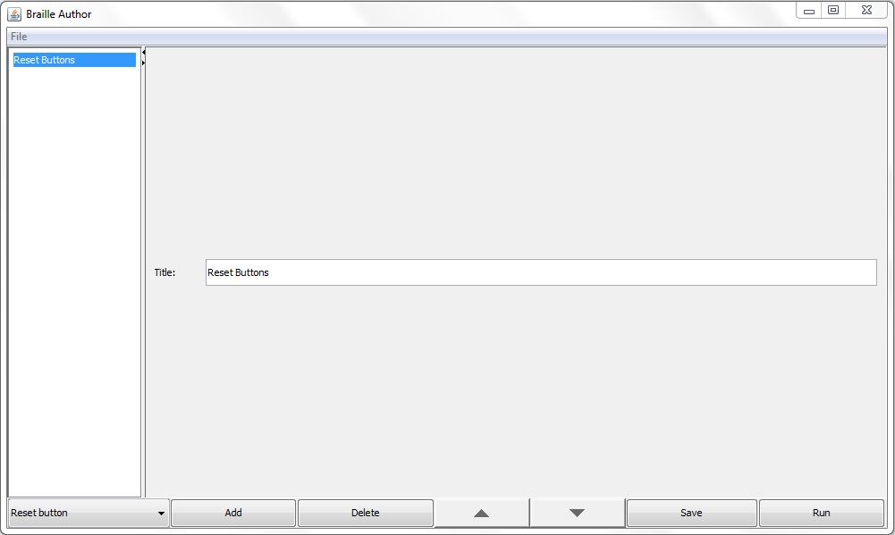

From here you may only customize the title of the interaction which will be displayed on its card on the left panel. The ‘Reset button’ interaction is needed to be used to clear any links that were made between buttons and keywords. This way if you linked button 1 to the keyword “ONE”, it could be reassigned to a new keyword in the future. Otherwise, button 1 will continuously bring them back to the keyword “ONE”.

## 2.09 - Customizing a ‘Clear braille’ Interaction

After adding a ‘Clear braille’ interaction, click on it in the left panel and you will see the editor for the interaction appear on the right panel like so:

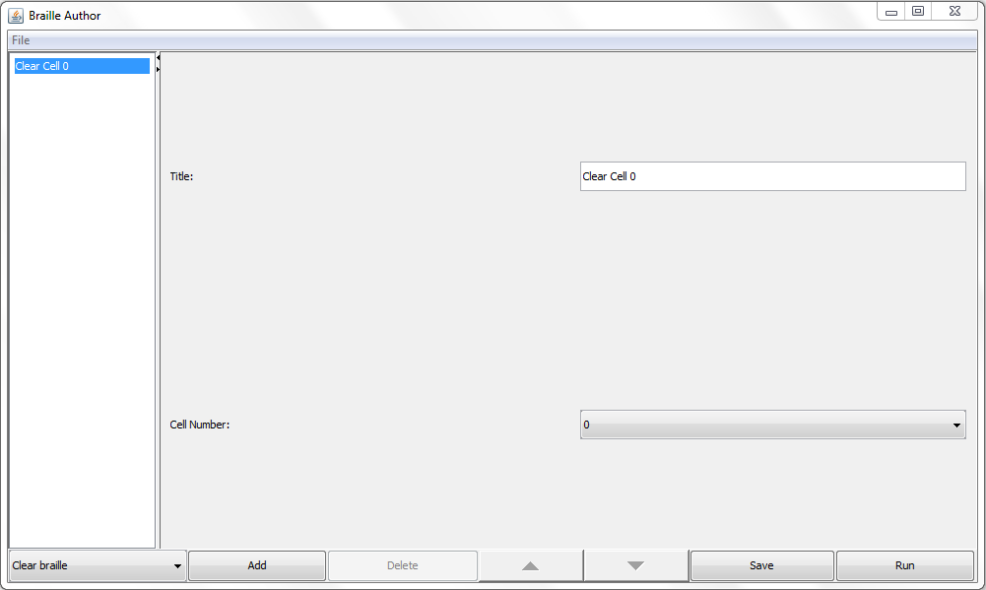

From here you may give the interaction a meaningful title to be displayed on its card on the left panel. You also may specify which cell you want to be cleared of its raised pins (eg. select 2 to clear the pins being displayed on the 2nd cell).

## 2.10 - Saving your Scenario

To save your scenario for later, click the ‘Save’ button. This will save the scenario in a .txt file to the directory that you ran the application from. It will include any updates you have made to the interactions within this scenario. Your scenario will **not** save automatically. Any changes you make by filling in or editing text in fields for interactions will not be saved until you click the ‘Save’ button.

## 2.11 - Running your Scenario

To run your scenario in the Enamel Braille Simulator (packaged along with Authoring App), click the test button. The test button will run only the most recent saved version - so if you have made changes to the interactions but haven’t saved them, they won’t show up in the simulator yet.